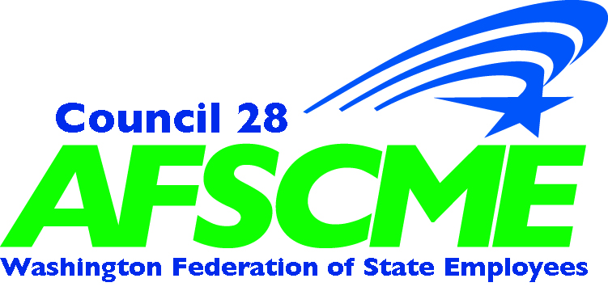

LEGISLATIVE & POLITICAL ACTION (LPA)
2024 TRAVEL GUIDELINES FOR LPA EVENTS

Please note that the LPA Travel & Reimbursement Policy for the 2024 legislative session & LPA events mirrors the WFSE Member Reimbursement Policy.

For approved travel accommodations, LPA will secure and pay for members who register for LPA events noted below. Contact Denise Mulholland, DeniseM@wfse.org to secure accommodations or ask questions.

WFSE Lobby Training, Saturday, January 6, 2024

- LPA will cover the cost of mileage or airfare & rental car (carpooling is highly encouraged when possible) and lodging for members attending the training. Note that pre-approval is required for reimbursement of airfare and car rental.
- For members with pre-approved overnight lodging, members must acquire a hotel folio upon check-out which is required to be provided with the member expense form for reimbursement. Please keep in mind that lodging accommodation is intended only for those who must travel greater than 50 miles to attend.
- For those traveling on a pre-approved overnight stay, one dinner meal will be reimbursed for the night prior to the event. All other meals that are not provided at the event are a member/local expense. All receipts must be ‘itemized’ to receive reimbursement.
- LPA provides breakfast, lunch and snacks.
- LPA does not pay time loss for this event.
- The RSVP deadline is Wednesday, January 3, 2024, 12 noon.
- This training will be held at South Seattle College, 6000 16th Avenue SW, Seattle, 98106, Brockey Center, 9:30am – 3pm.
- Register here: https://actionnetwork.org/events/lobby-training-2024/

WFSE Member Lobby Days
The 2024 Legislative Session runs from Monday, January 8, 2024, through Thursday, March 7, 2024 – 60 days.

- LPA will cover the cost of mileage or airfare & rental car (carpooling is highly encouraged when possible) and lodging for members coming to Olympia for their scheduled Lobby Day and if LPA requests that a member testify at a legislative hearing. Note that pre-approval is required for reimbursement of airfare and car rental.
- All lodging must be pre-approved, and members must acquire a hotel folio upon check-out which is required to be provided with the member expense form for reimbursement. Please keep in mind that lodging accommodation is intended only for those who must travel greater than 50 miles to attend.
- For those traveling on pre-approved overnight lodging, one dinner meal will be reimbursed for the night prior to the event. All other meals that are not provided at the
event are a member/local expense. All receipts must be ‘itemized’ to receive reimbursement.
- LPA does not pay time loss for this event.
- LPA provides breakfast, lunch and snacks during Lobby Days.
- Member Lobby Days are held at the LPA Office, 906 Columbia St. SW, Olympia, in the LPA 5th floor large conference room.
- Register here: https://actionnetwork.org/campaigns/2024-wfse-lobby-days-2

WFSE Legislative Reception, Tuesday, January 17, 2024

- LPA has never paid for mileage/travel to attend the reception as this is an optional event for WFSE PEOPLE members.
- Deadline to RSVP is Wednesday, January 10, 2024, 12 noon. Members who RSVP must be WFSE PEOPLE members.
- LPA does not pay time loss for this event.
- The reception will be held at the Octapas Heritage Room, 610 Water St. SW, Olympia.
- Register here: https://actionnetwork.org/events/wfse-legislative-reception-2024/

Endorsement Conference, Saturday, April 27, 2024

- LPA will cover the cost of mileage or airfare & rental car (carpooling is highly encouraged when possible) and lodging for members coming to the training. Note that pre-approval is required for reimbursement of airfare and car rental.
- Please keep in mind that lodging accommodation is intended only for those who must travel greater than 50 miles to attend. For those traveling on a pre-approved overnight stay, one dinner meal will be reimbursed for the night prior to the event. All receipts must be ‘itemized’ to receive reimbursement.
- LPA does not pay time loss for this event.
- LPA provides breakfast, lunch and snacks. All other meals are a member/local expense.
- Deadline to RSVP is Tuesday, April 15, 2024.
- This conference will be held at South Seattle College, 6000 16th Avenue SW, Seattle, 98106, Brockey Center, 10am – 3pm.
- Register here: https://actionnetwork.org/events/wfse-endorsement-conference/

Questions?
For approved travel accommodations, LPA will secure and pay for members’ who register for LPA events. Contact LPA to discuss any situation not specifically covered above. Lack of resources should never be a barrier to member participation. We’re happy to partner with members and locals whenever possible. Contact Denise Mulholland DeniseM@wfse.org.

